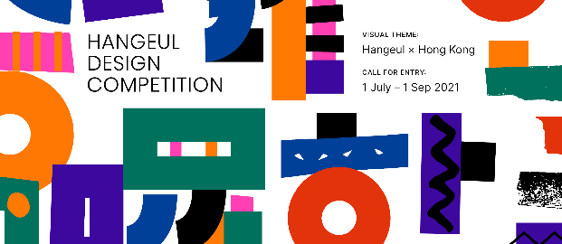 |  | Hangeul Design Competition 2021  Application Form
1) Personal Information
Name | Note: Full English Name |  | Date of birth | YYYY/MM/DD
Contact Number | Ex. (+852) 0000-0000 |  | Occupation | *Please also specify the full name of your affiliation & position if possible
Email
HKID Card Number |  |  | Nationality
Category | *Duplicate application is not allowed  *Please fill in all members’ personal information below if you apply as TEAM  *Please attach relevant documents (ex. portfolio OR any kind of proof) if you apply as PROFESSIONAL  Participating Type:  Individual Team (Maximum of 4)  Participating Session:  General Professional (1 year or above relevant experience)
Team Member 1
Name | Note: Full English Name |  | Date of birth | YYYY/MM/DD
Contact Number | Ex. (+852) 0000-0000 |  | Occupation
Email
HKID Card |  |  | Nationality
Team Member 2
Name | Note: Full English Name |  | Date of birth | YYYY/MM/DD
Contact Number | Ex. (+852) 0000-0000 |  | Occupation
Email
HKID Card |  |  | Nationality
Team Member 3
Name | Note: Full English Name |  | Date of birth | YYYY/MM/DD
Contact Number | Ex. (+852) 0000-0000 |  | Occupation
Email
HKID Card |  |  | Nationality
2) Details of participating work
Work Title
Work Description | *Describe your work in terms of theme, relevance between your work and Hangeul x Hong Kong (English, Max 200 words)
3) Declaration of Applicant
In submitting the application form with signature, the applicant fully and unreservedly agrees to all the terms, clauses and conditions as follow:
1. General applicants confirm that they fully satisfy each of the below entry requirements:
- have a valid HKID at the time of application
- have (a) less than one year’ full time or part time or freelance professional design experience, or (b) are not student or graduate at a design or art-related institute.
2. Professional applicants confirm that they fully satisfy each of the below entry requirements:
- have a valid HKID at the time of application
- have (a) more than one year’ full time or part time or freelance professional design experience, or (b) are student or graduate at a design or art-related institute.
3. Applicants must ensure that the information provided is true when submitting the application form.
4. Applicants confirm that all works submitted are original and will be created entirely themselves. Applicants also confirm that their designs have not yet been seen in public. Applicants understand that the competition will assume no liability for the work they have submitted, accusations of plagiarism, copyright issues, or any intellectual property rights issues related to the entries and work submitted by any third party. The applicants take sole responsibility and they shall fully indemnify the competition for any loss or damages incurred as a result of such claims. Applicants understand that in this case their admission to the competition shall be terminated and any winning titles will be revoked.

5. Applicants consents to the use of design of award-winning work for non-profit making purpose including promotion activities, exhibitions, production and distribution of production by the Korean Cultural Center in Hong Kong and Yang Won Sun Foundation.

6. By taking part in the competition, applicants grant the Korean Cultural Center in Hong Kong full rights to use the submitted work for exhibition at the center. Only works selected by judges will be exhibited, and the Korean Cultural Center in Hong Kong will contact the applicants of selected works individually.

7. Applicants understand that the Korean Cultural Center in Hong Kong reserves the right to limit, refuse or withdraw any applicant at any stage of the competition if they are found to have violated any of the terms and conditions of entry listed herein.
8. Applicants’ all personal information will be used solely for the purposes of the competition unless otherwise agreed in advance with the applicant.
9. Applicants understand that the Korean Cultural Center in Hong Kong reserves the right to change or cancel the scheduled date(s) and the prize(s).

I hereby confirm that the contents in the application are true and correct, I will assume full responsibility for problems arising from indicating false information and acknowledge that the award may be canceled, or the prize may be recovered in such case.
______________ (Month) ______________ (Date), 2021
Full name of the person above ______________ (Signature)
Hangeul Design Competition in Hong Kong 2021

Letter of Consent on Provision and Use of Personal Information
The Korean Cultural Center in Hong Kong seeks for consent on collection
and use of personal information for the ‘Hangeul Design Competition’ as below:
Purpose of collection and use of personal information | Verification, screening, individual notices of the results, awarding etc.
Collection items of personal information | * Name, date of birth, HKID card, contact information, e-mail address, and any other kind of personal documents
Processing and use period of personal information | * Disposing personal information immediately after achieving the purpose of collection and use of personal information  * Personal information of award winners will, however, be stored for two years from the date of termination of the offline event (Oct. 9, 2021)
Right of denying consent and disadvantages from non-consent | * Applicant is entitled to deny consent on collection, use and provision of his/her personal information mentioned above upon his/her own discretion  * Participant denying the consent will, however, be excluded from participation, evaluation and awarding
Do you consent on collection and use of personal information?
Yes ( ), No ( )
______(Month) ______(Date), 2021

Name : (Signature) Date of Birth :
Korean Cultural Center in Hong Kong

